**18U ENCLOSURE 19" CABINET 600X1000 | 18U SERVER RACK CABINET FLOOR STANDING**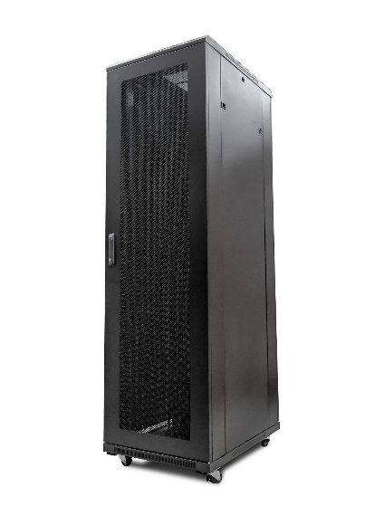

**CAB-FE-18U-6100**

**DESCRIPTION**

Redefining quality compact ergonomics for server and networking

Looking to house your latest rackmount Server, SAN, UPS and other networking devices in a compact, universal server enclosure?

The new LMS Data CAB-FE-18U-6100 | 18U Server Rack Cabinet Floor Standing is one of the most compact server enclosures on the market today, but still has all the features IT integrators come to expect

from its larger counterparts. Full 19-inch wide, front and rear adjustable profiles

with a thicker gauge designed to carry the extra weight of a fully populated

server and of course, full 1000mm depth to house high--performance

servers but also allow adequate airflow.

Air-flow is further enhanced with front meshed door to allow ambient air

to be allowed to enter the active equipment and of course an integral

roof-fan tray will extract heated air safely away from the equipment, thus

increasing available up time for your mission-critical application

**SPECIFICATIONS**

* ETSI 19” front/rear profiles (adjustable)
* Universal server design for all popular servers, UPS, SAN & more*
* Up to 800Kg static load bearing**
* Front mesh high venting door (lockable)
* Left/right hinged front/rear doors
* Removable side panels for easy access
* U-numbered uprights for rack-mount product alignment
* Multiple cable entry glands for exact power and cabling entry
* Fitted 4-way fan tray in raised and vented roof-space
* Fitted vented shelf
* Powder-coated RAL 9005 finish
* Weight: 50.0 Kg
* Dimensions: 600x100x980mm